**SW Engineering CSC648/848 Section 01 Spring 2018**

**PARSE**

Pollution and Accident Reporting for a Safer Environment

**Milestone 5**

May 21st, 2018

**Team 04**

Rodrigo Bell (rbell594@gmail.com)

Charlie Tuttle

Rohan Patel

Dion Matthew Lagos

Kamran Khadivi-Dimbali

Michael Schwiebs

Zhenru Huang

Table of Contents

Product Summary 3

Milestone 1 4

Milestone 2 15

Milestone 3 29

Milestone 4 30

Product Screenshots 41

Database Screenshots 48

Google Analytics Screenshots 49

Team Member Contributions 50

Post Analysis 52

# Product Summary

PARSE is a website tool made by our team of 7 students at San Francisco State University. Our web-based service specializes in raising awareness about local environmental issues in San Francisco. A few of our functional specs:

* Ability to browse site as a guest user
* Guest users can register for an account using username and encrypted password
* Registered users can upload environmental issues for others to see
* All users can search for issues using zip code and category
* Admins are the only ones able to manage the database

Our website can be accessed at the following URL: <https://csc648-team04.herokuapp.com/>

**SW Engineering CSC648/848 Section 01 Spring 2018**

**PARSE**

Pollution and Accident Reporting for a Safer Environment

# Milestone 1

February 28, 2018

**Team 04**

Rodrigo Bell (rbell594@gmail.com)

Charlie Tuttle

Rohan Patel

Dion Matthew Lagos

Kamran Khadivi-Dimbali

Michael Schwiebs

Zhenru Huang

*Revisions*

|  |  |
| --- | --- |
| February 28, 2018 | Initial Draft |
| March 5, 2018 | Revision after instructor feedback, Frozen |

**Table of Contents**

**Executive Summary . . . . . . . . . . . . . . . . . . . . . . . . . . . . . 3**

**Use Cases . . . . . . . . . . . . . . . . . . . . . . . . . . . . . . . . . . 4**

**Data Definitions . . . . . . . . . . . . . . . . . . . . . . . . . . . . . . . 5**

**High-Level Functional Requirements . . . . . . . . . . . . . . . . . . . . . . 6**

**High-Level Non Functional Requirements . . . . . . . . . . . . . . . . . . . . 7**

**Competitive Analysis . . . . . . . . . . . . . . . . . . . . . . . . . . . . . 8**

**System Architecture . . . . . . . . . . . . . . . . . . . . . . . . . . . . . 9**

**Development Team . . . . . . . . . . . . . . . . . . . . . . . . . . . . . 10**

**Checklist . . . . . . . . . . . . . . . . . . . . . . . . . . . . . . . . . . 11**

**Executive Summary**

Some of our most valued experiences take place in the natural landmarks our cities have to offer. San Francisco alone has over 220 parks that people have been enjoying for years. Maintaining these parks and our general environment has always been important step towards keeping our children and the local wildlife safe. Unfortunately, in this modern age, these natural environments can be tainted by garbage and hazardous materials.

PARSE started with the belief that technology should help clean our planet, not pollute it. With the number of environmental problems that are seen in many cities and parks today, it can be difficult for the average person to bring these issues to the attention of the public and proper authorities. The goal of PARSE is to close this communication gap by providing a web application with a quick and detailed reporting system.

PARSE is a web application that allows everyday people to report an environmental problem that they may have witnessed, such as misplaced garbage or hazardous spills. These reports can be detailed with a location, physical description, and any supplementary photos. All of this done in a quick and straightforward manner without any extensive setup on the user’s end, and PARSE’s makes it easy for the user to submit a report from their smartphone within minutes.

These reports can be easily viewed by anyone by simply visiting our website. The user can search for an environmental issue by location or keyword, and the results that follow will display any unresolved issues. The content itself can be managed by Content Moderators, who can use PARSE to open and close issues as they see fit.

The people at PARSE are proud to call Earth our home, and like many people, we care that our home is clean. We believe that PARSE can bring the people of any city or town together by providing them with an easy way to bring environmental issues to light, and together they can address them in a professional manner.

PARSE was started by a team of seven student developers, including five undergraduate students and two graduate students. The project’s CEO is Dragutin Petkovic, Associate Chair and Professor of the Computer Science department at San Francisco State University, and the CTO is Anthony Souza, former graduate student and current lecturer at SFSU. This team has a wealth of experience in web development and software engineering. With all of the members living in the San Francisco Bay Area, we have an strong appreciation of the natural beauties this area has to offer. Our goal is to keep our oceans, parks, and cities clean of all hazardous waste and litter, and with PARSE, we believe we can make that a reality.

**Use cases**

**1. Unregistered User**

Rebecca is an activist who is passionate about caring for the environment. Looking for ways she can help around her local community in San Francisco, she begins searching online for issues currently occurring in the area. Upon examining the results returned by a search engine, she finds and visits ***CSC-648 Team 04’s Website***. Here she can see all of the current listings of environmental problems that have been posted by the local residents of San Francisco who are registered on the site. From here she will be able to browse by a location, keyword, or category, and find any issues she may be interested in becoming involved with. After selecting an issue, she shall be able to view more details about it, including pictures, specific location, and any other information regarding the subject.

**2. Registered User**

Any registered user on ***CSC-648 Team 04’s Website*** will be able to post an environmental issue than can be viewed by the public after approval. This allows residents to report issues in the area that normally would not have been brought to public attention otherwise. An example of includes John, a father of two who enjoys biking around the city with his children. One day as he and his kids are riding around town, they decide to take a lesser known bike trail that runs by a creek that leads into a water supply for local farmers to grow crops. While on the trail, John and his children notice that someone had dumped a large amount of motor oil into the creek, threatening the water supply connection further down the stream. John then decides to take action by taking a picture of the scene and logging onto his computer at home to report the issue. After using the UI tools to add details about the issue, he is then prompted to create an account in order to post it.

**3. Environmental Service Company / Content Moderator**

**Any company or organization that works to combat environmental issues can use *CSC-648 Team 04’s Website* as a tool to help further their work. PARSE** is a local organization that aims to educate people on environmental hazards and ways they can decrease their amount of consumption and waste. Using the website as a tool, they can survey neighborhoods and regulate the issues, being able to confirm/approve content and close open issues. They can also use this website to assign a specific issue to a unit or team to work on fixing it. Furthermore, they will be able to evaluate priority of issues and assess which issues need to be addressed first.

**Data Definitions**

**Unregistered user:** Able to view environmental issue posts. No login required.

**Registered User:** Same abilities as unregistered user AND is able to post about environmental

problems in a specific neighborhood. Account must be created with email, username and password. Must login to access personal posts, saved posts.

**Environmental Service Company/ Content Moderator:** Same ability as registered user AND can update status on a post. Also has access Priority Issue Tool. Account created with email, username, password, Service company verification.

**Administrator:** Same ability as registered user AND can manage user accounts and delete inappropriate content. Ensures the proper user and content policies are followed.

**Environmental Issues Posts (Visible to all):**

* Images of issue/exact location
* Section to add keywords for other users searching
* Maps/location/address
* Description of problem
* Search tool
* Option for user to save a post

**Priority Issue Tool (Environmental Service Company use only):**

* Analytics for service company to evaluate priority of issues

**Bookmarks:** Registered users may save viewed listings for later viewing. Registration will require email, username, and password.

**High-Level Functional Requirements**

**Unregistered Users (guests):**

1. Application shall display location of posted environmental issues on Google Maps
2. Application shall provide a search functionality filtering by city, state, or zip code
3. Application shall allow guests to register for a User or Service Company account.
4. Application shall display new and pending environmental incident listings.

**Registered Users (in addition to unregistered user functions):**

5. Users shall be required to register with full name, email, and password.

6. Users shall be able to provide a photo and a description of the environmental issue.

7. Users shall have permission to create postings of environmental issues to the database.

8. Users shall have a log of reported, pending, and resolved issues saved to their account.

**Administrator:**

9. Administrators shall have permission and power to remove postings

10. Administrators shall have the permission and power to remove any type of account or listing.

**Service Company:**

11. Service company accounts shall have access to a dashboard to choose which issues to resolve.

12. Listings can only be resolved by Service Company accounts or Administrators.

## 

## 

## 

## 

## 

**High-Level Non-Functional requirements**

1. Application shall be developed and deployed using SW stack approved by class CTO Anthony Souza.
2. Application shall be hosted and deployed on Heroku as approved by Anthony.
3. Application shall be optimized for standard desktop/laptop browsers, i.e., must render correctly on the latest versions of all major browsers: Chrome, Safari, Mozilla
4. Application shall have responsive UI code so it can be adequately rendered on mobile  
   devices but no mobile app is to be developed.
5. Data shall be stored in the MySQL database on the server in the team's Heroku account.
6. Maps showing location of the environmental issue shall be provided.
7. No more than 50 concurrent users shall be accessing the application at any time.
8. Privacy of users shall be protected and all privacy policies will be appropriately communicated to the users.
9. The language used shall be English.
10. Application shall be very easy to use and intuitive. No prior training shall be required to use the website.
11. Google analytics shall be added.
12. Site security: basic best practices shall be applied (as covered in the class).
13. Modern SE processes and practices shall be used as specified in the class, including collaborative and continuous SW development.
14. Paid site features shall not be implemented.
15. The website shall prominently display the following text on all pages “SFSU Software Engineering Project, Spring 2018. For Demonstration Only.”

**Competitive Analysis**

|  |  |  |  |  |
| --- | --- | --- | --- | --- |
| Feature | Epa | Lema | Broward | PARSE |
| Text Search | + | + | + | + |
| Search Filtering | ++ | - | - | ++ |
| Mobile End | - | + | ++ | ++ |
| User Login | - | - | - | + |
| Report Violation | ++ | - | ++ | ++ |
| Browse | + | + | + | ++ |

*+ feature exits*

*++ superior feature*

*- feature does not exist*

As the table was showed above, our product provides a great user experience by comparing to other competitive products exit on the market right now. Our product has a better search design and user interface design which can provide an easier access for our user. And it may bring more potential users. And our users can report environment issues easily by using our product and protect our environment better.

**System Architecture**

**Development Stack**

* Server Host: Heroku 1x CPU 512 MB RAM
* Operating System: Ubuntu 16.04 Server (We're using Heroku which is a PaaS but it uses ubuntu internally)
* Database: MySQL 5.7
* Web Server: Node JS Server with Express
* Server-Side Language: Javascript

**Frameworks & APIs**

* Express - Minimal and flexible Node.js framework for serving web content
* Bootstrap - Front-end web development framework for responsive interfaces
* Google Analytics - Google API offering accurate website statistics

**Version Control:** Git (v 2.16.2)

**Development Team**

Rodrigo Bell, *Team Lead*

Charlie Tuttle, *Front-End Lead*

Rohan Patel, *Back-End Lead*

Michael Schwiebs, *Front-End Dev*

Kamran Khadivi-Dimbali, *Front-End Dev*

Dion Matthew Lagos, *Back-End Dev*

Zhenru Huang, *Back-End Dev*

**Checklist**

* Team decided on basic means of communications - DONE
* Team found a time slot to meet outside of class - DONE
* Front and back end team leads chosen - DONE
* Github master chosen - DONE
* Team ready and able to use the chosen back and front end frameworks - DONE
* Skills of each team member defined and known to all - DONE
* Team lead ensured that all team members read and understand the final M1 - DONE

**SW Engineering CSC648/848 Section 01 Spring 2018**

**PARSE**

Pollution and Accident Reporting for a Safer Environment

# Milestone 2

March 18, 2018

**Team 04**

Rodrigo Bell (rbell594@gmail.com)

Charlie Tuttle

Rohan Patel

Dion Matthew Lagos

Kamran Khadivi-Dimbali

Michael Schwiebs

Zhenru Huang

*Revisions*

|  |  |
| --- | --- |
| March 18, 2018 | Initial Draft |
| March 26, 2018 | Revised after instructor feedback - Frozen |

**Table of Contents**

**Data Definitions . . . . . . . . . . . . . . . . . . . . . . . . . . . . . . . 5**

**Functional Requirements . . . . . . . . . . . . . . . . . . . . . . . . . . . 6**

**UI Mockups and Storyboards . . . . . . . . . . . . . . . . . . . . . . . . . 7**

**High-Level Architecture . . . . . . . . . . . . . . . . . . . . . . . . . . . . 8**

**Database Organization . . . . . . . . . . . . . . . . . . . . . . . . . . . . 9**

**UML Diagrams . . . . . . . . . . . . . . . . . . . . . . . . . . . . . . . 10**

**Project Risk Assessment . . . . . . . . . . . . . . . . . . . . . . . . . . . . 11**

**Data Definitions**

**Unregistered user:** Able to view environmental issue posts. No login required.

**Registered User:** Same abilities as unregistered user AND is able to post about environmental

problems in a specific neighborhood. User registration data requires email, username and password. Must login to access personal posts, saved posts.

**Administrator:** Same ability as registered user AND accept and delete environmental issues. Ensures the proper user and content policies are followed.

**City Environmental Manager:** Same ability as registered user AND can update status on a post. Also has access Priority Issue Tool. The development team will assign and manage site administrators.

**Environmental Issues Posts (Visible to all):**

* Images of issue
* Maps/location/address
* Description of problem
* Option for user to save a post
* Category of issue

**Priority Issue Tool (City Env. Manager use only):**

* Dashboard for service company to evaluate priority of issues

**Functional Requirements**

**Priority 1 – MUST HAVE**

**Unregistered Users (guests):**

1. Users shall display listings of posted environmental issues on Google Maps.
2. Users shall provide a search functionality filtering by keywords.
3. Users shall allow guests to register for a User account.
4. Users shall display new and pending environmental incident listings.

**Registered Users (in addition to unregistered user functions):**

5. Users shall be required to register with full name, email, and password.

6. Users shall be able to provide a photo and a description of the environmental issue.

7. Users shall have permission to create postings of environmental issues to the database.

**Administrator:**

9. Administrators shall have permission and power to remove postings.

10. Administrators shall have the permission and power to remove any type of account or listing.

**City Environmental Manager:**

11. Development team shall have access to a dashboard to list users, issues, and be able to set the issue status.

12. Listings can only be resolved by Service Company accounts or Administrators once the environmental issue is no longer a concern.

**Priority 2 – MEDIUM IMPORTANCE**

**Unregistered Users (guests):**

1. Application shall provide a search functionality filtering by address, zipcode, or category.

**Registered Users (in addition to unregistered user functions):**

1. Users shall have a log of reported, pending, and resolved issues saved to their account.
2. Users shall be able to make bookmarks of environmental issues.

**UI Mockups and Storyboards**

**Landing Page  
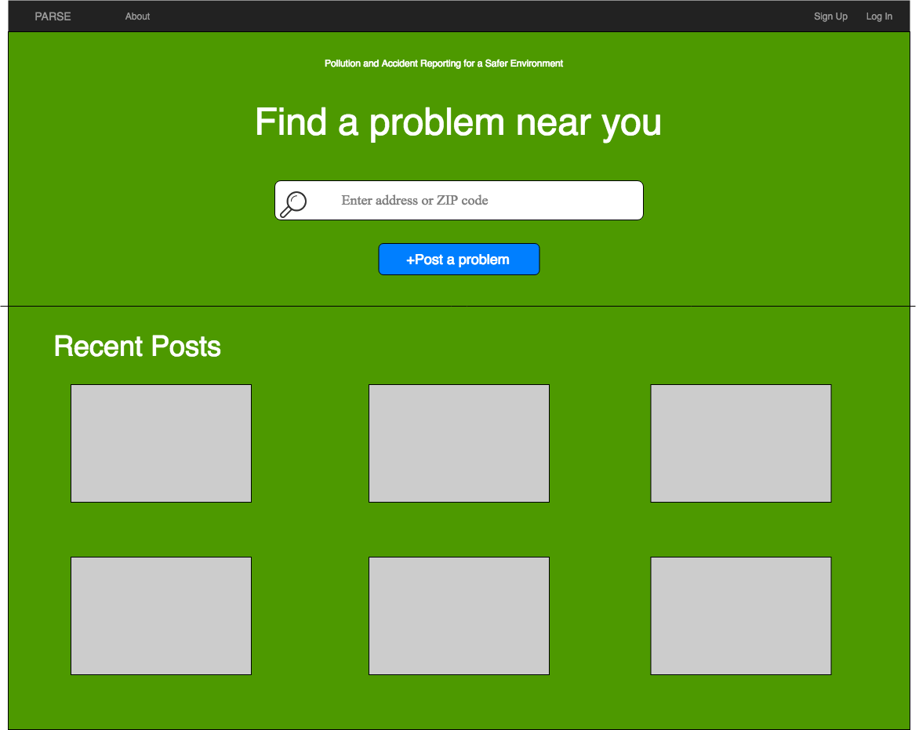**

**Use Cases**

* **Unregistered User:** Able to search/view posts, sign up in the top right corner.
* **Registered User:** Able to sign in at top right corner, post/search/view a post.
* **Service Company:**Same abilities as registered user.

**Search Results Page   
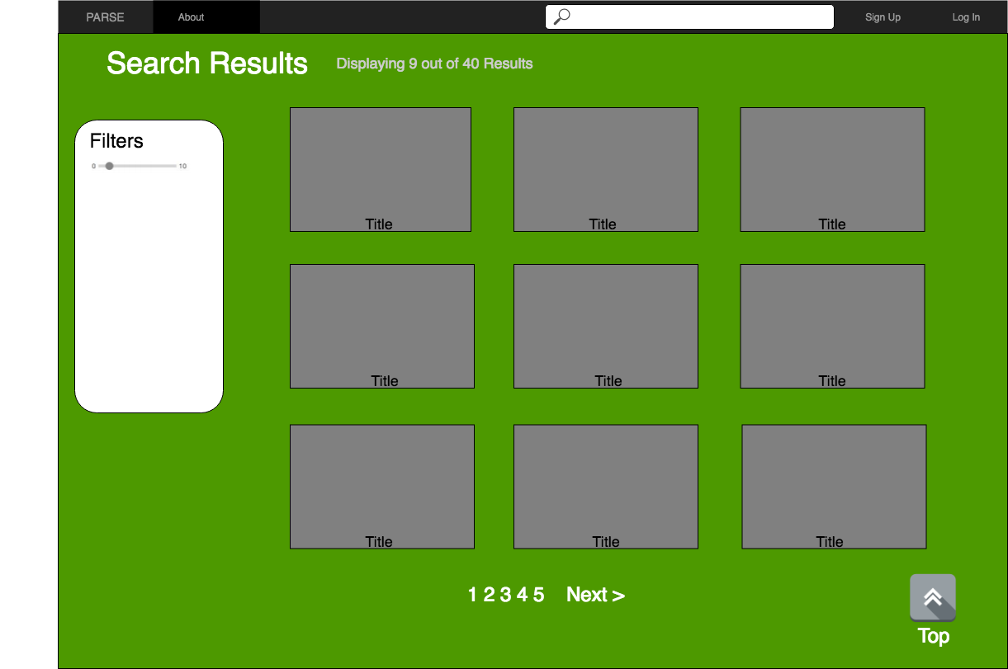**

**All users:** This page shows the listings according to the search. You can also refine the search by using the filter tool, with specifications coming in the future. The user can go to the next page by clicking the “Next>” button or clicking the page number. Search bar is included if the user wants to do a different search.

**Individual Post Page**

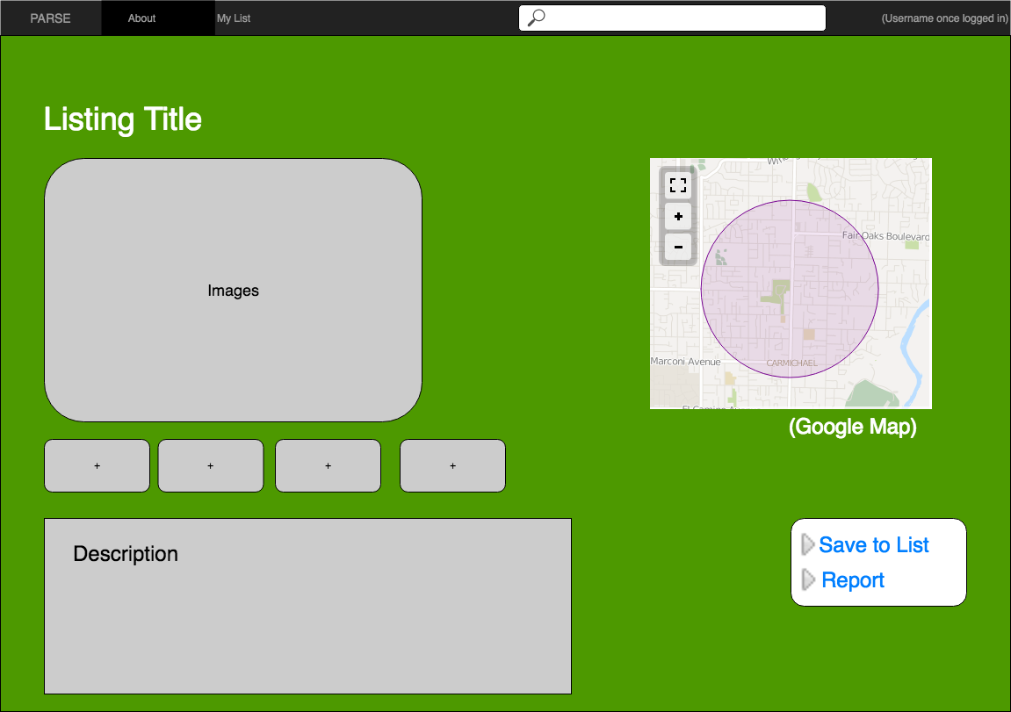

**Unregistered User:** Can only view the post.

**Registered User and Service Company:** Able to save to their personal list and report the post if it does not abide to the terms of agreement.

**Login Page**

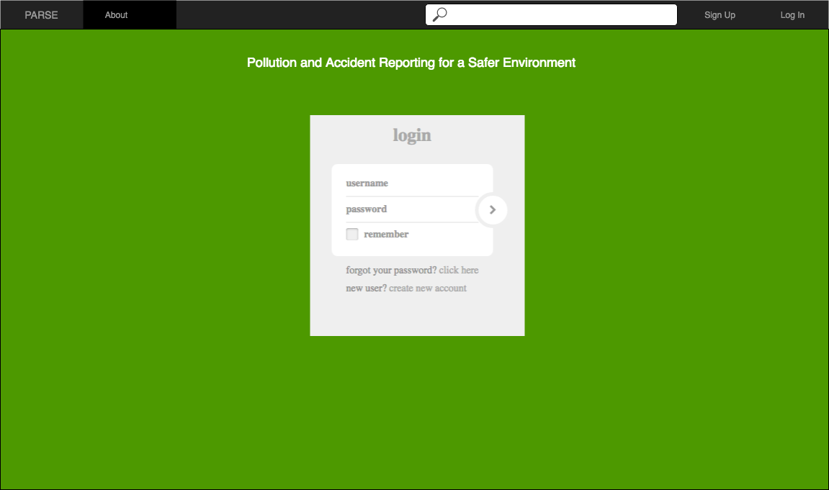

**All Users:** Registered users enter their username and password.

**Sign Up Page**

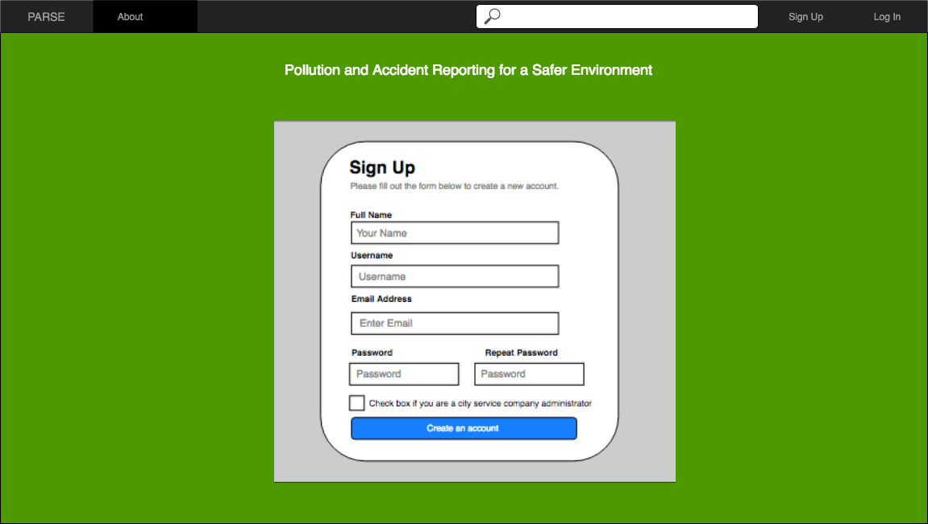

**All users​:** Sign up by filling the following form. If you are from the service company, you check the box as you finish creating your account.

**High-Level Architecture**

For this project, we will use the general MVC pattern which is under Express framework in Node JS.

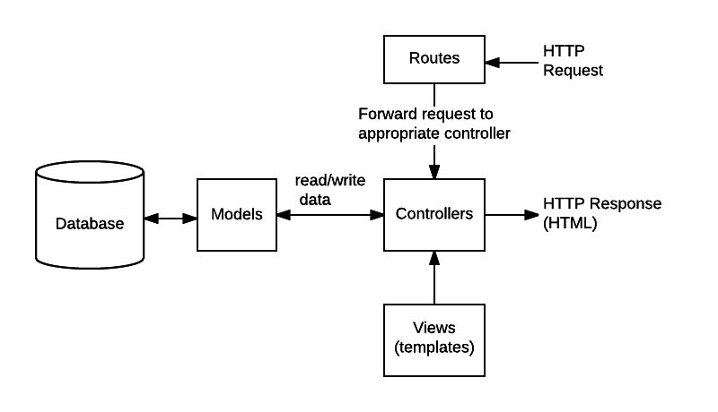

*Source: https://developer.mozilla.org/en-US/docs/Learn/Server-side/Express_Nodejs/routes*

The diagram shows the MVC pattern we are going to use for our project. First user will send a HTTP request to our Controller. And with this request, the Controller will request the Model to call the Database to get the data that the user request. And then the Model will send the data back to our Controller. Finally, our Controller will use these response data and render them into our View templates and send it back as HTTP or HTML response.

**Database Organization**

**Schema**

**category issue user**

-id(PK) -id(PK) -user_id(PK)

-name -title -name

-category(FK) -email

-description -phone

-zipcode -password

-image -isAdmin

-isApproved

-isResolved

-user_id(FK)

-latitude

-longitude

**Image System**

For images, we will use the file system to store it. We will have a path for images source. Once the users try to add images, the images will all be uploaded to our cloud under this path. And our database system will store the path and name of these image files. And once we try to use these images, we can easily pull up their path from out database and get it from our server.

**Search Architecture**

For search system, we will have a drop down menu for categories, so users can filter their results with different category. And also the users can type in the zip code and get the results of nearby.

**UML Diagrams**

**Class Diagram**

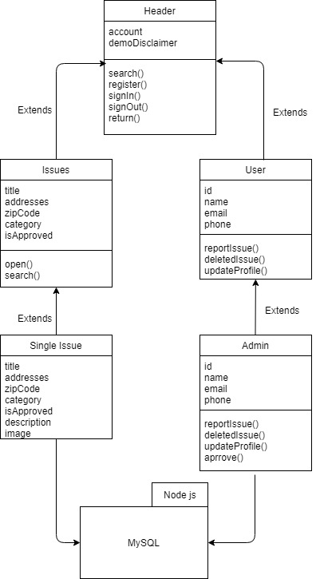

**View Flow Diagram**

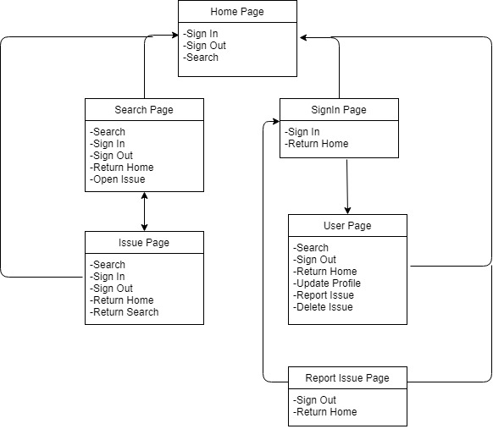

**Component and Development Diagram**

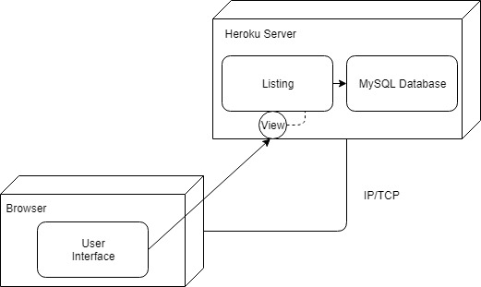

**Project Risk Assessment**

Upon review of the organization of the PARSE web application and its development team, the following risks have been identified:

* *Skills risks*: the majority of the team is unfamiliar with the given development stack (node.js/express) for the project, and may need accommodate time to gather and learn from various resources.
* *Schedule risks*: as the development team is comprised of senior level undergraduate students, scheduling conflicts may emerge due to individual projects or jobs.
* *Legal/content risks*: this project requires the use of media (uploaded images) which may potentially infringe upon the rights of its owners.

In order to resolve the identified risks, SCRUM-style meetings will be held between the team lead and the rest of the team weekly either online or in person to discuss any issues with the application development. At scheduled extended meetings, we will periodically review the coding procedures that need to be done, and research the methods of accomplishing them within the chosen framework and development stack. Code reviews will be conducted within the smaller teams to resolve any coding issues. The back-end team will work together to document a vertical prototype and educate the rest of the team.

During the weekly SCRUM-style meetings, we discuss availabilities for the week and plan for any scheduling conflicts that may arise with any of the members. To ensure deadlines are met, tasks are assigned with soft deadlines depending on the availabilities discussed. An extended weekly meeting is typically scheduled to discuss issues in depth at these meetings. We will keep the scope of the project to a minimal P1 set as development continues on.

For demo purposes, our project will use images of properties. In order to avoid any legal issues, all images must be reviewed by team leads before pushed to the live project site. The sources will be checked for the distributive rights of the images - only commercial-free (and no attribution required) images will be approved for demo use.

# Milestone 3

**Instructor to Check and comment below:**

* Git/GitHub organization (e.g. organization of branches) GH organization file wise looks good. Branches are better used for features instead of per-member branches but this is OK.
* Git/GitHub usage: Comments on positing; Number of posting to GitHub; Apr. even distribution of submissions among team members (check GitHub post stats for all members)  Commit messages look good, little to few duplicate messages. Distribution is OK some members have a low number of commits.
* Code documented (header, in code) with good coding style Little to no comments, no file headers.
* MVC/OO patterns followed up Followed.
* Frameworks (back end front end) deployed correctly Seems to be deployed correctly.
* Database organization (tables, naming...) Table names are OK, usually they are plural, user should be users, but this is a small issue.
* Blobs being used? If so, is it working? Image paths are used.
* Adherence to best practices of security (PW encrypted, search inputs verified etc.) Passwords seem to be encrypted now. Inputs looks not to be verified,
* Efficiency (proper use of image thumbnails, efficient search eytc.) Looks good.
* Other

**SW Engineering CSC648/848 Section 01 Spring 2018**

**PARSE**

Pollution and Accident Reporting for a Safer Environment

# Milestone 4

May 17th, 2018

**Team 04**

Rodrigo Bell, Team Lead (rbell594@gmail.com)

Charlie Tuttle

Rohan Patel

Dion Matthew Lagos

Kamran Khadivi-Dimbali

Michael Schwiebs

Zhenru Huang

**Table of Contents**

**Product Summary . . . . . . . . . . . . . . . . . . . . . . . . . . . . . . 3**

**Usability Test Plan . . . . . . . . . . . . . . . . . . . . . . . . . . . . . . 4**

**QA Test Plan . . . . . . . . . . . . . . . . . . . . . . . . . . . . . . . . 6**

**Code Review . . . . . . . . . . . . . . . . . . . . . . . . . . . . . . . . . 8**

**Self-check: Security . . . . . . . . . . . . . . . . . . . . . . . . . . . . . 10**

**Self-check: Non-functional Requirements . . . . . . . . . . . . . . . . . . . . 11**

**Product Summary**

PARSE is a web application that strives to be a simple to use listing platform for local environmental issues. With PARSE, people can easily check for environmental issue wherever they go in the city.

PARSE provides a simple and easy to use set of features:

* All guests can view environmental issues right from the PARSE home page
* Anyone can easily search for issues by typing in a zipcode or category in the search bar.
* Issues provide plentiful information and images with Google Maps integration.
* City managers have access to a simple to use dashboard making it simple to set the issue status.
* Explore the PARSE web application at: csc648-team04.herokuapp.com

**Usability Test Plan**

**Test Objective**

* The objective of this test is to gauge the usability of the site’s main function: Search.
* Expose flaws with the Search function by asking our testers to perform the search task with no prior instructions. The testers will need to intuit how to use the Search function in order to search for the targeted queries.

**Test Plan**

**System setup**

* Tester will log into a computer with access to the internet and access to the following accepted internet browsers: Google chrome or Firefox.

**Starting point**

* Tester will begin at the site homepage wherein a search button will be present.

**Task to be accomplished**

* Tester will attempt a search for listings in a city of their choosing.
* Tester will attempt a search for listings with a zip code of their choosing.

**Intended Users**

* The targeted user is broad, as any person who is searching for a property is a potential customer.
* Users will be assumed to have no technical expertise and may be a complete novice to web browsing.

**Completion criteria**

* Tester is satisfied that they have accomplished the search query they attempted. This is evaluated from a post test questionnaire.

**Usability** **Questionnaire**

**I found the Search function intuitive and easy to use (Check one)**

**__** Strongly Disagree __ Disagree __ Neither Agree or disagree __ Agree __ Strongly Agree

**It was easy and intuitive for me to find the listings for the Categary I was searching for (Check one)**

**__** Strongly Disagree __ Disagree __ Neither Agree or disagree __ Agree __ Strongly Agree

**It was easy and intuitive for me to find the listings for the zip code I was searching for (Check one)**

**__** Strongly Disagree __ Disagree __ Neither Agree or disagree __ Agree __ Strongly Agree

**Comments:**

**QA Test Plan**

**Test Objective**

1. The objective of this test is to validate the functioning of one of the primary features of the website, i.e. Search.
2. The tester shall be given specific instructions to follow and the results shall be recorded as a PASS/FAIL in each of the individual cases.

**Hardware and Software setup**

1. The tester should have access to a device that supports recent versions of two web browsers – Google Chrome and Mozilla Firefox.
2. The devices used should be connected to internet via Wi-Fi, Ethernet, Cellular, etc.
3. The internet connection speed should be adequate (at least 2.5MBps) for flawless browsing experience.
4. And finally, the user should open the following link on either of the prescribed browsers to begin the test.

**Features to be tested**

This test will solely focus on the Search feature of the website. The Search feature shall be operated by inputting a query in the search field on the very top of the homepage of the website. The permitted inputs are names of cities or the zip-codes.

|  |  |  |  |  |  |  |
| --- | --- | --- | --- | --- | --- | --- |
| **Test #** | **Test title** | **Description** | **Test input** | **Expected output** | **Result (Chrome)** | **Result (Firefox)** |
| 1. | Zip-code search | Tester shall input the prescribed zip-code number into the search bar and the results shall be validated through comparison with the expected output. | 94112 | 1 result with retrieved item having 94112 as zip code | PASS | PASS |
| 2. | Category search | Tester shall input the prescribed name of city into the search bar and the results shall be validated through comparison with the expected output. | “Accident” category selected | 3 results with retrieved item having “Accident” category selected | PASS | PASS |
| 3. | Zip-code and category search | Tester shall input the prescribed zip-code and issue category in the search bar and the results shall be validated through comparison with the expected output | 94112 with “Pollution” category selected | 1 result with retrieved item having “Pollution” category and 94112 zip code | PASS | PASS |

**Code Review**

A code review was conducted on the basic implementation the Node.js app entry point. Specifically, this code review shows the code to setup our MySql connection to the database.

In order to ensure clear code, indentation styles is used with 4 spaces for indentation.

**Feature:** Database setup

**Submitted by:** Rodrigo Bell

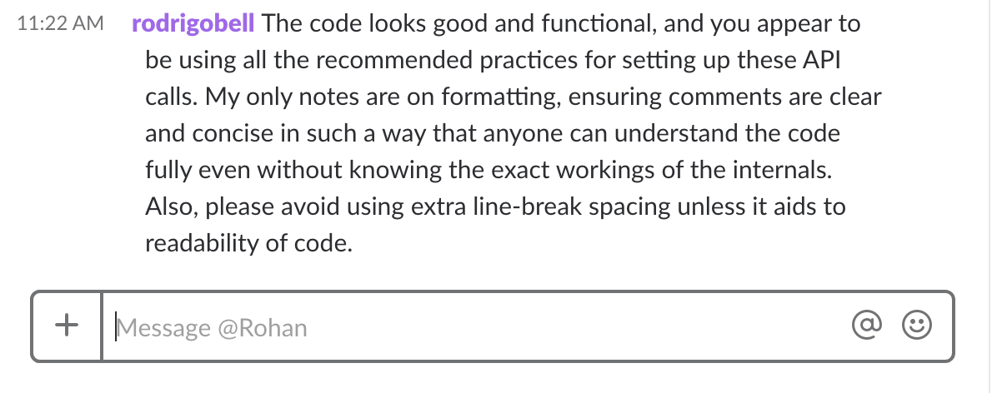

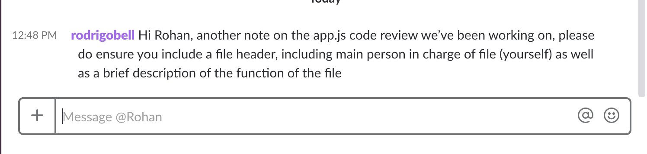

/app.js

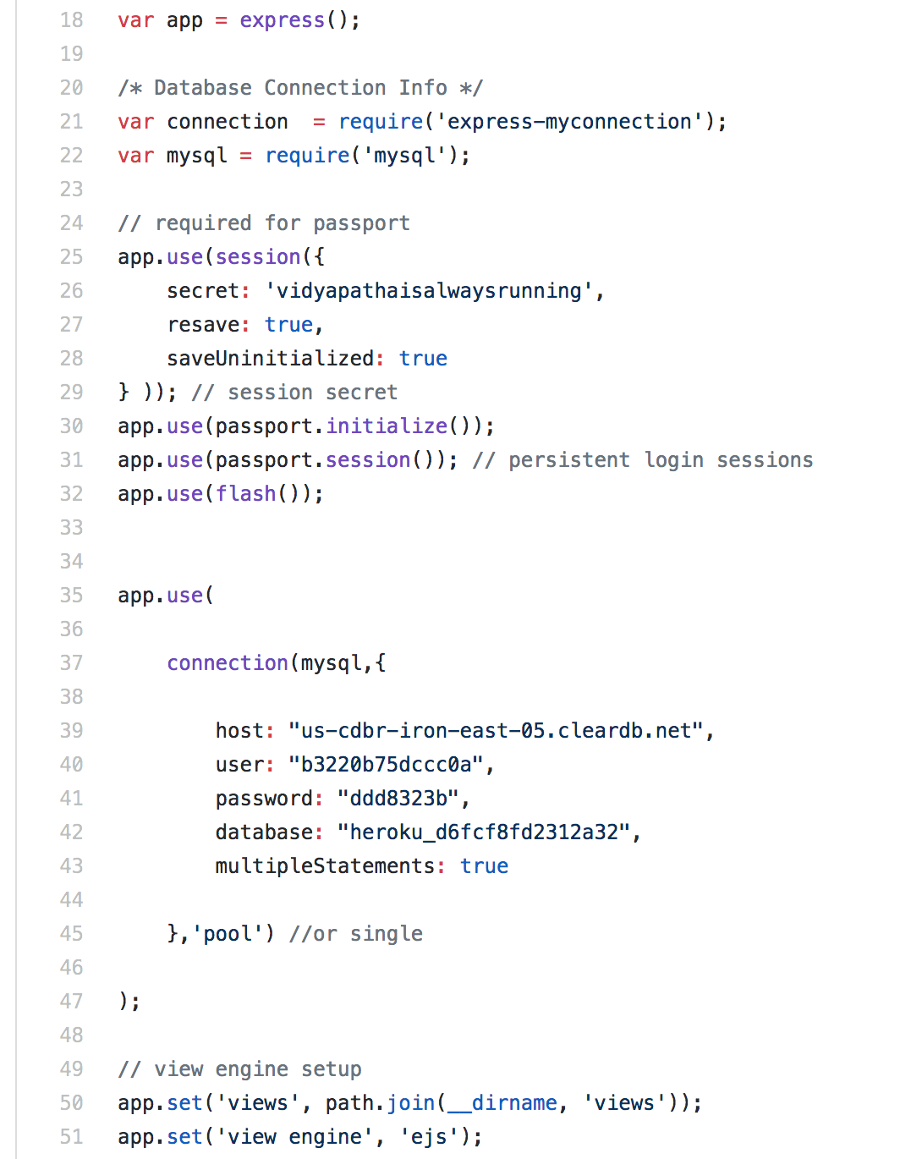

**Self-check: Security**

**Major Assets Being Protected**

* Name
* Username
* Password

**Passwords**

Passwords are hashed, and no plain-text passwords are stored in the database. Name and username are protected and only accessible by database admin.

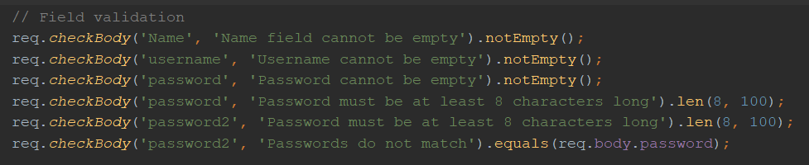

**Self-check: Non-functional Requirements**

|  |  |  |
| --- | --- | --- |
| 1 | Application shall be developed and deployed using SW stack approved by class CTO Anthony Souza. | DONE |
| 2 | Application shall be hosted and deployed on Heroku as approved by Anthony. | DONE |
| 3 | Application shall be optimized for standard desktop/laptop browsers, i.e., must render correctly on the latest versions of all major browsers: Chrome, Safari, Mozilla | DONE |
| 4 | Application shall have responsive UI code so it can be adequately rendered on mobile devices but no mobile app is to be developed. | DONE |
| 5 | Data shall be stored in the MySQL database on the server in the team's Heroku account. | DONE |
| 6 | Maps showing location of the environmental issue shall be provided. | DONE |
| 7 | No more than 50 concurrent users shall be accessing the application at any time. | DONE |
| 8 | Privacy of users shall be protected and all privacy policies will be appropriately communicated to the users. | ON-TRACK |
| 9 | The language used shall be English. | DONE |
| 10 | Application shall be very easy to use and intuitive. No prior training shall be required to use the website. | DONE |
| 11 | Google analytics shall be added. | DONE |
| 12 | Site security: basic best practices shall be applied (as covered in the class). | ON-TRACK |
| 13 | Modern SE processes and practices shall be used as specified in the class, including collaborative and continuous SW development. | DONE |

# Product Screenshots

**Home Page**

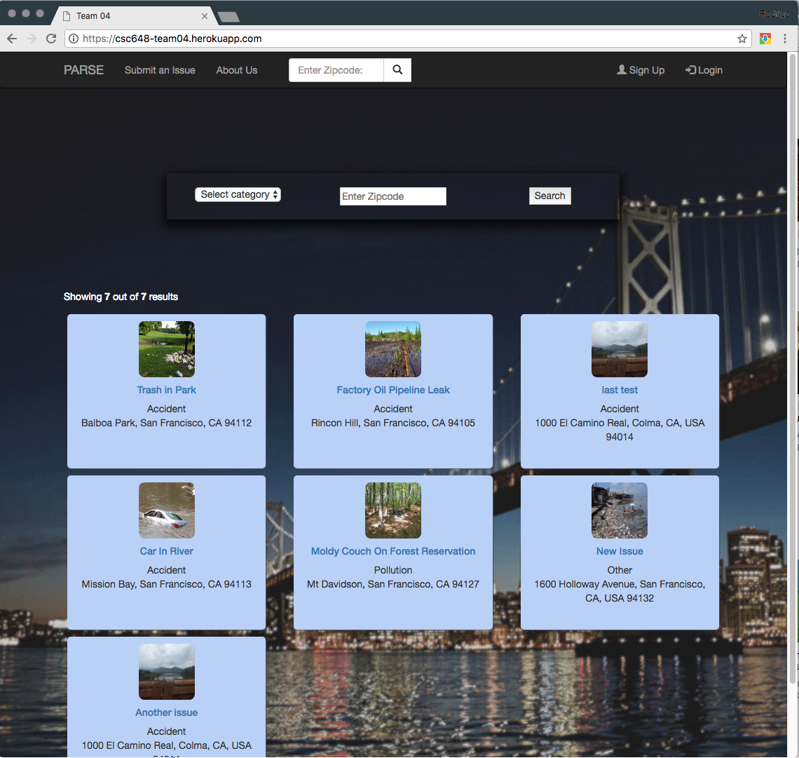

**Issue Details Page**

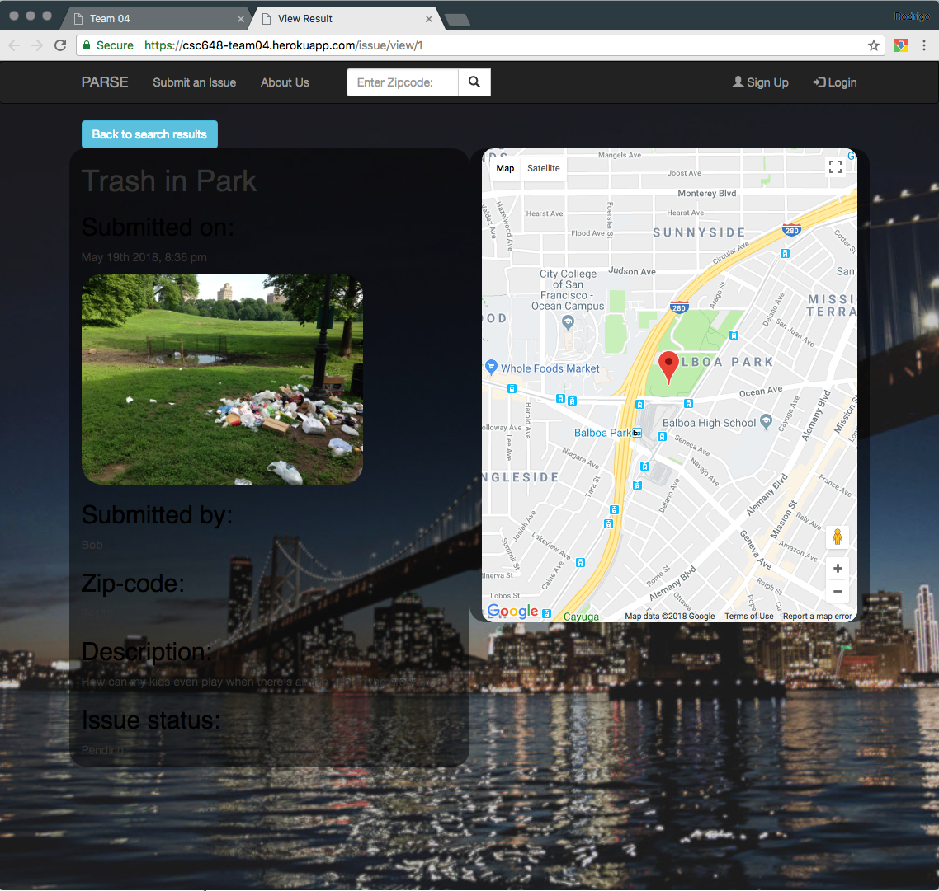

**Search Results Page**

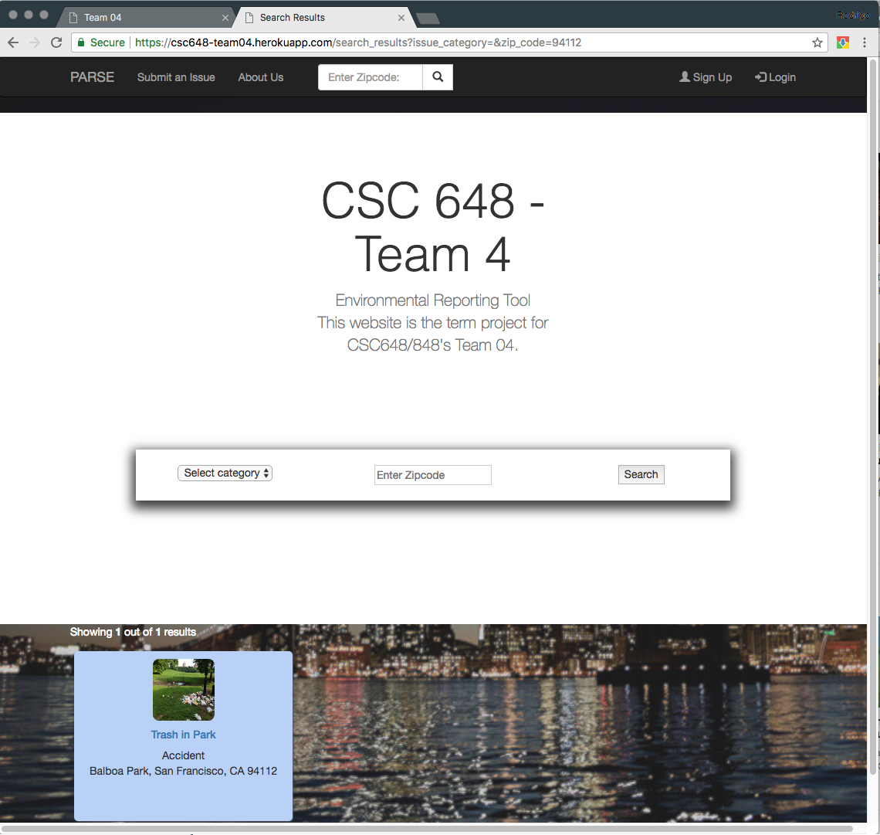

**Issue Submission Page**

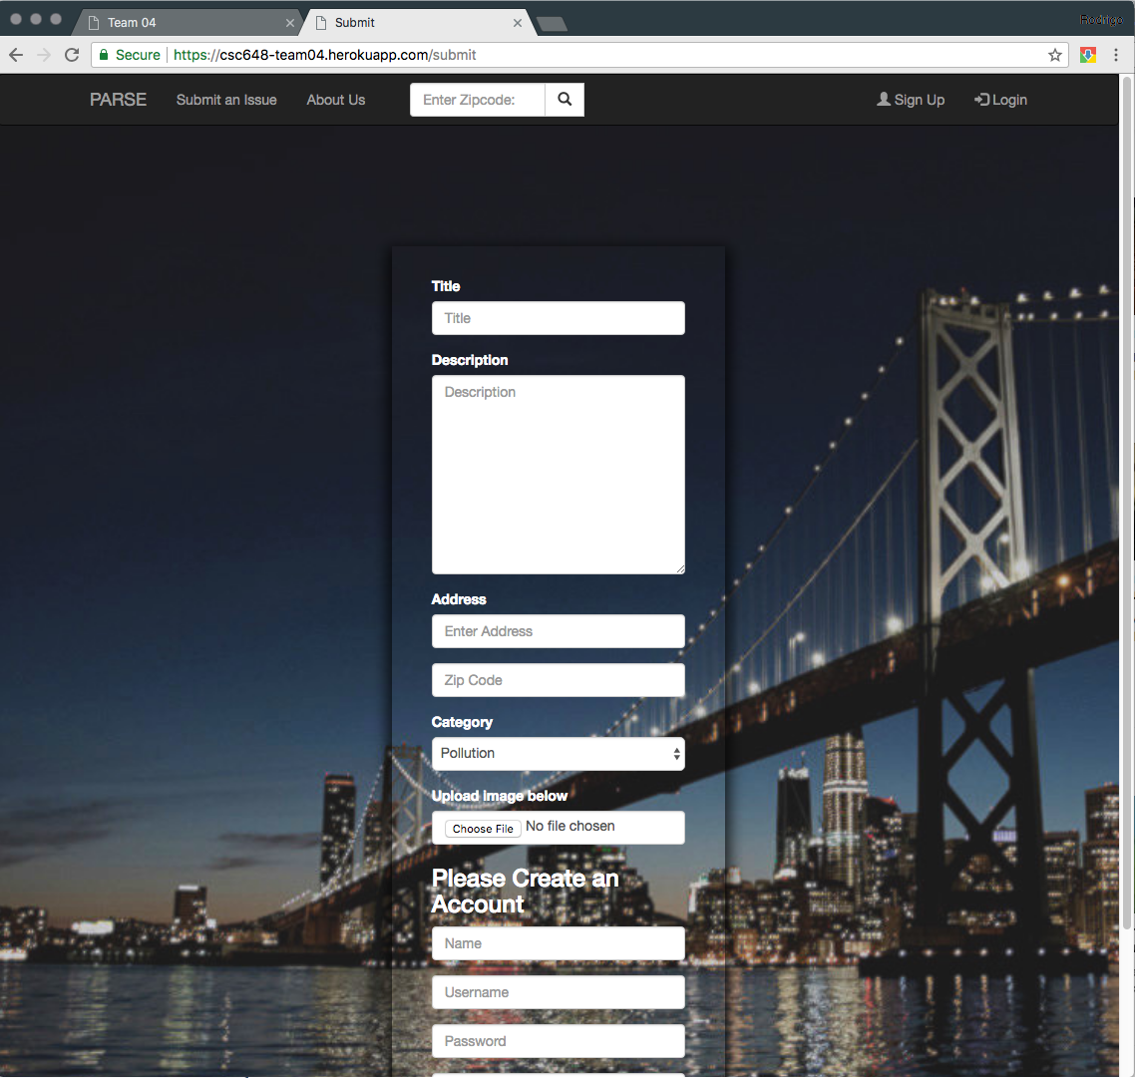

**Registration Page**

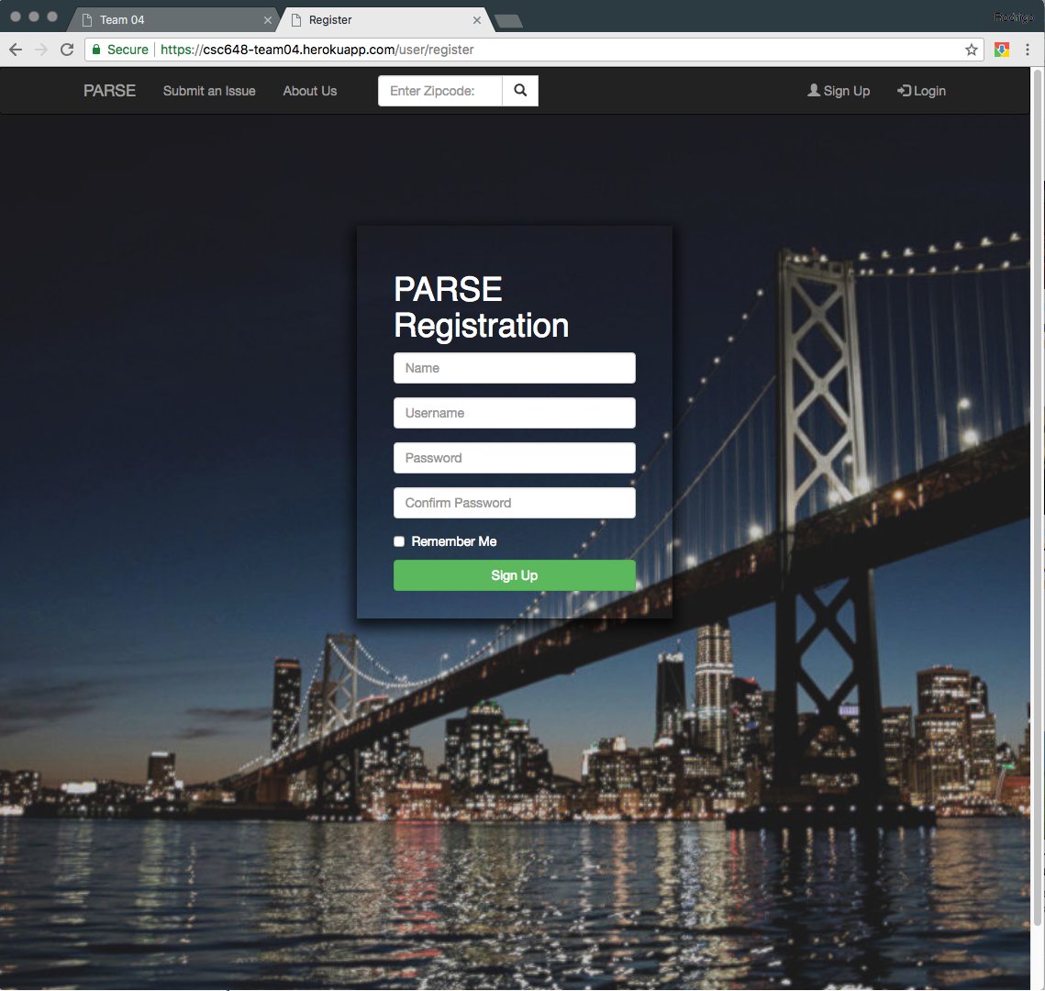

**Login Page**

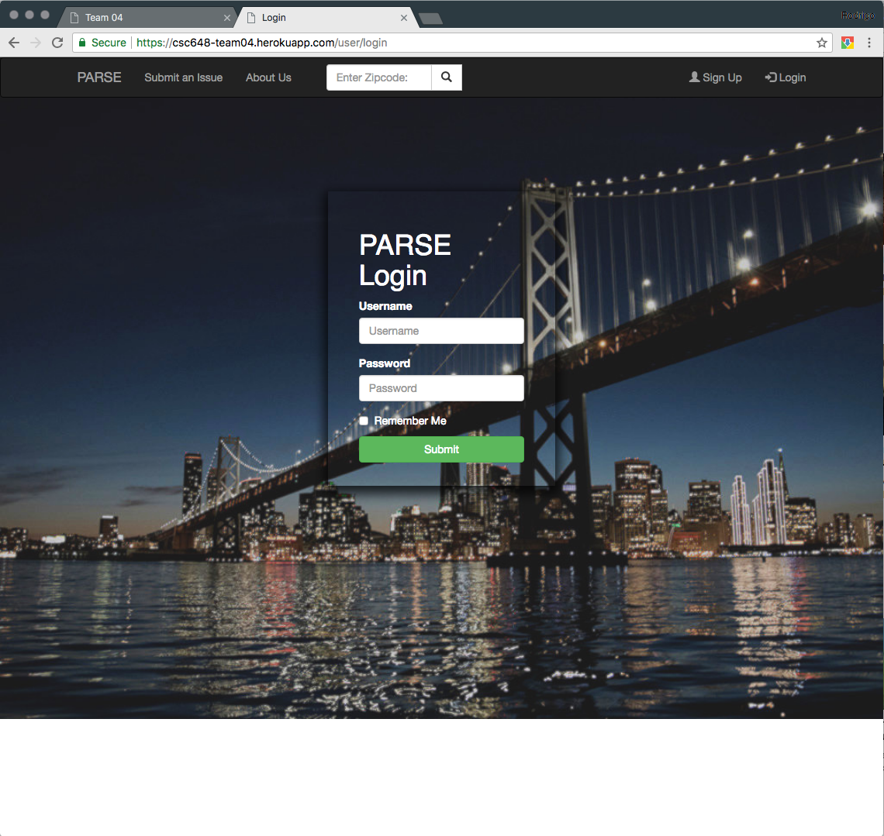

**User Logged In Welcome page**

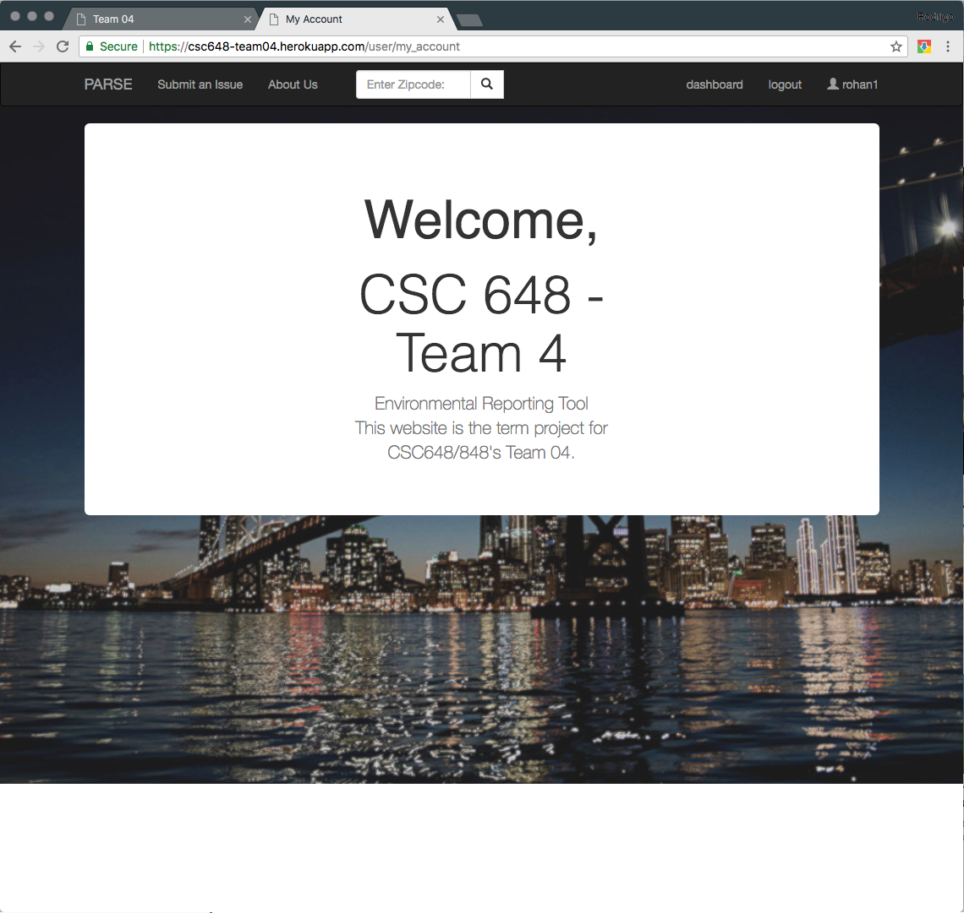

# Database Screenshots

**User**

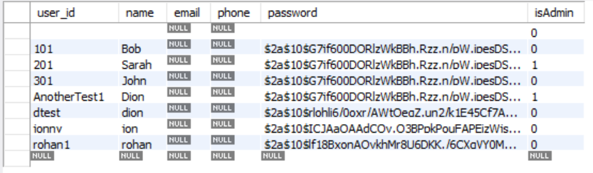

**Status**

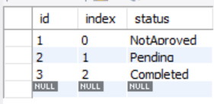

**Issues**

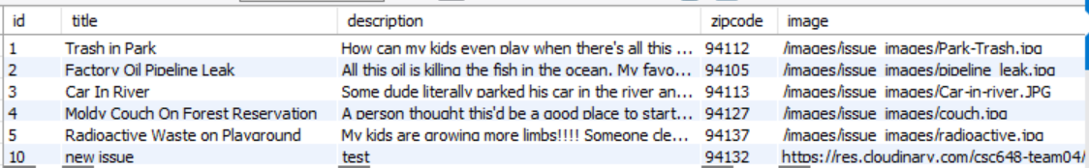

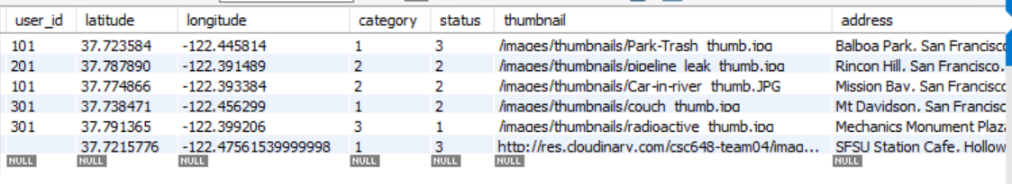

**Category**

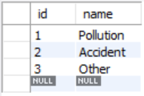

# Google Analytics Screenshots

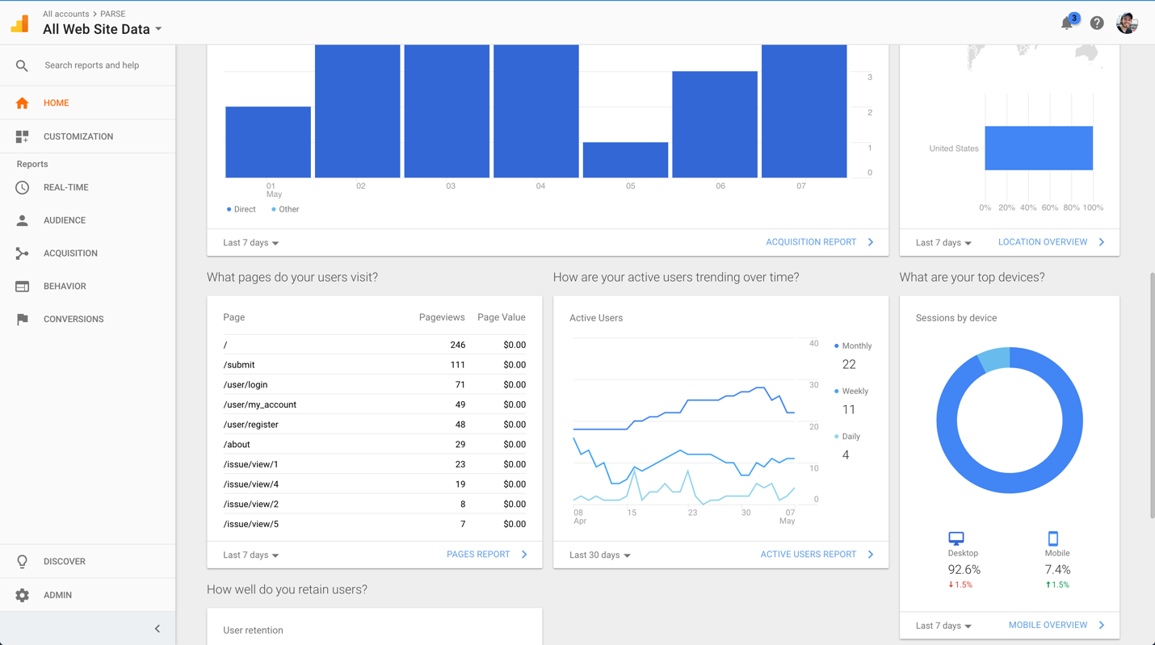

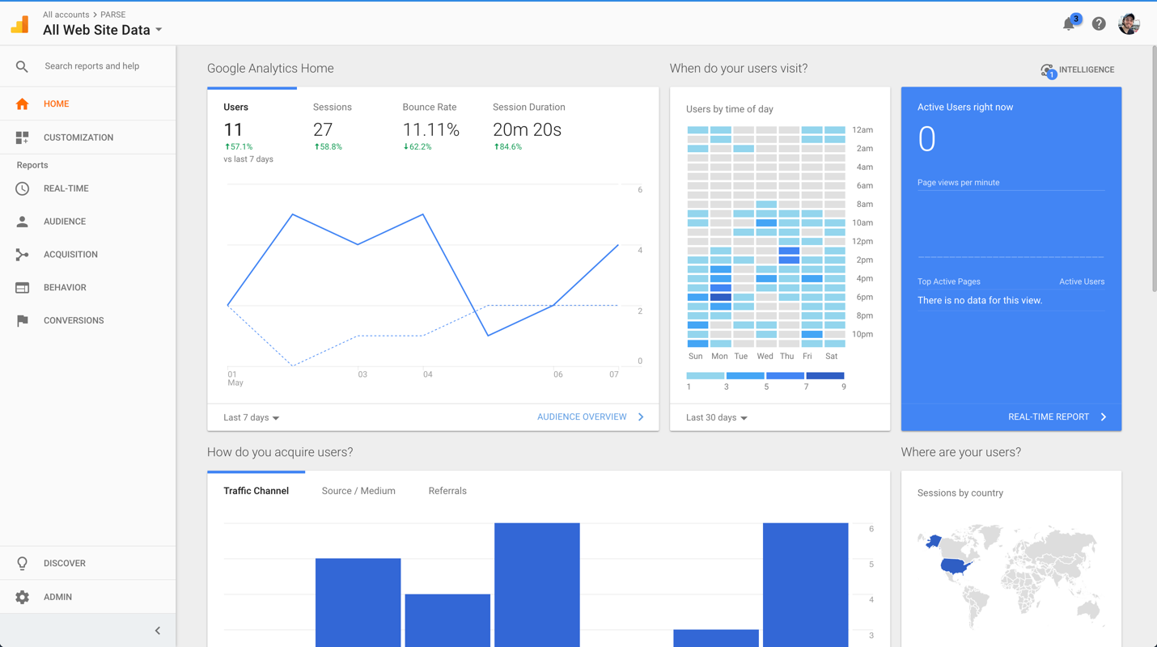

# Team Member Contributions

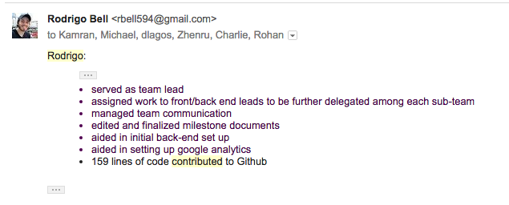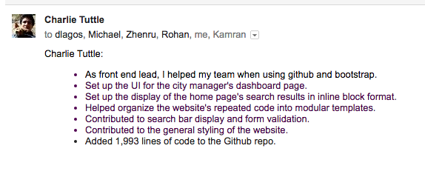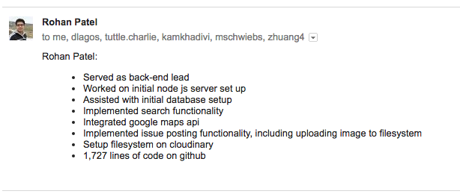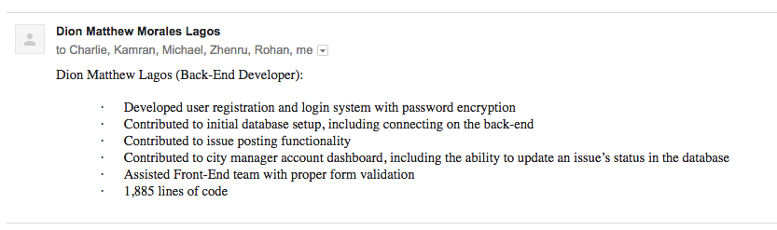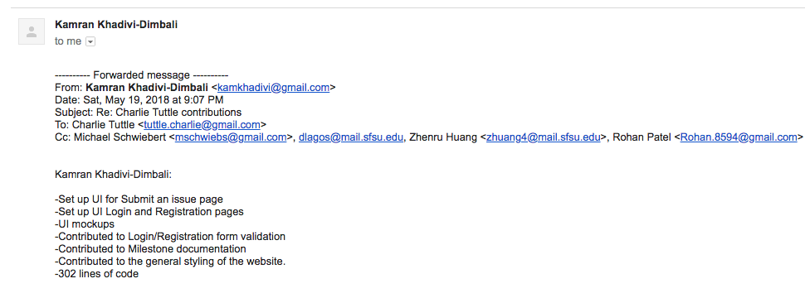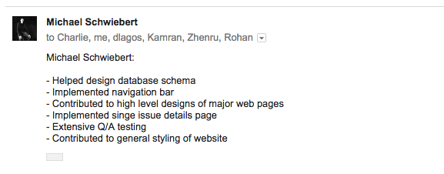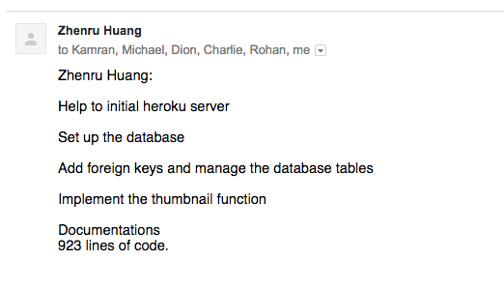

# Post Analysis

This project was a great exercise in learning how to come together as a team on a large scale software engineering project. Many of us had multiple scheduling conflicts outside of class times which prevented us from finding a recurring time to meet as a whole team. We overcame this by scheduling work meetings on the fly at different times, and in smaller groups (e.g. front-end specific, back-end specific meetings). We also used Slack as our primary means of communication which we found to be very effective.

Going back, we could have improved our communication even more by setting a scheduled standup earlier in the project. We also could have chosen a different framework that is better documented and easier to work with.

Overall, the project went very smoothly, and every team member was able to pull their own weight, which meant that we were very productive as a team.